The Inside Story
Carlton United Brewery (CUB) site on Broadway in Chippendale

The Carlton United Brewery (CUB) site is a long standing industrial site that has operated in Chippendale for over 150 years. Operations ceased in 2003 following Fosters (the owner) decision to sell the site to developers.

The industrial site, approximately 6 hectares in size, represents nearly 20% of the village area and visually dominates Chippendale. Adjacent to the Chippendale Heritage Conservation area, the site is located metres from 2 storey Victorian terraces and low-rise pre and post war industrial architecture. The site’s current industrial and heritage buildings support Chippendale’s unique character.

In 2002, Chippendale’s residential population was approximately 3,000 with another 1,100 workers (taking in Regent and Lee Streets to the north east). The proposed CUB redevelopment threatens to triple the existing population. Together with more recent developments, Chippendale faces the danger of having one of highest population densities in Sydney.
CUB site – part of Chippendale

Existing planning controls for the greater part of Chippendale restrict development to 6 -12 metres, with a smaller part of the village allowing 15 - 25 metres (to the north -east along Regent & Lee Streets).

The village however has serious environmental challenges. It has the least amount of open space per resident in Sydney and carries some of Sydney’s most heavily trafficked roads. Nearly 1.7 Million vehicle movements go through Chippendale each week, a large part heavy freight movement that quarantines the suburb and cuts it into two precincts.
Importantly, given the site’s prominence, any substantive high rise will block local vistas and overshadow the village with the community largely reliant on its street vistas for sunlight and public space in the absence of parklands and backyards.

To maximise their return for the site, Fosters want to change the current planning controls because the current height limit (45 metres) hinders developers from maximising their return. The current density (Floor Space Ratio - FSR) allows for a range up to 5.1, dependent on land use. This is a maximum, not a guarantee.

Here the inclusion of privately owned roads, previously sold off by the COS, is included in the FSR. This has effectively inflated the FSR, leading to owner/developer expectations we believe are not achievable, driving scare tactics about the current controls. Coupled with exponential property prices over recent years, Foster’s “windfall” is at Sydney’s expense.
Consequently, when the real estate market was at its highest in 2003, Fosters sold the site for $203M. This was conditional upon planning changes being achieved. The sale subsequently did not go ahead after the market crashed.
Negotiations to change the controls have continued with a Design Competition held in order to establish what controls are possible. The outcome: a Jury Report highlighting concerns that any significant height increase, i.e. over 45 metres, compromises local vistas and amenity. In short, a suggested density of 4.4 to 1 used for the Design Competition - was seen as not socially or environmentally sustainable.

This led to further studies, with Council’s consultants determining the site could only support a maximum density of 3.5:1 on the site. However State Government appointees on the CSPC pushed for the density to be increased to 4:1. (This Committee is State Government controlled and determines large projects under Council’s jurisdiction.)

The result: a proposed density range of 3.5:1 - 4:1. However, this must be exhibited for public comment before any new Local Environment Plan (LEP) can be finalised and approved. At the time, when the CSPC endorsed the draft controls for public exhibition, it was made apparent that unless an FSR of 4:1 was achieved, there simply wouldn’t be any park/open space. As a consequence, the FSR range of 3.5 to 4 was endorsed for exhibition, despite concerns, this would result in an FSR of 4 to 1, plus a potential bracket creep on top.
One of the key issues for this site’s redevelopment is the preservation of the heritage buildings (which the community endorses) as well as the need for open space (including roads), parks and amenity. This in turn impacts where height and massing of buildings can go. As a consequence, multiple high rise towers will be squashed together unless there is a reduction in FSR to offset the provision for heritage, open space and parklands. Without a reduction in FSR or the ability to take FSR from this site and on sell it elsewhere, this means the density is shifted from one part of the site, inflating the height elsewhere.

Unfortunately, the CSPC did not reduce the height controls from that used in the brief for the Design Competition, which was rejected by the Jury. Nor did it consider suggestions to shift the FSR off site to ensure that sustainable controls are achieved. Height controls in the draft LEP, remain at 100 metres despite leading experts saying these cannot be supported.

However, these are proposed controls which were to be exhibited for public comment, before any new controls can be finalised. Here, the exhibition of the draft LEP was delayed because a draft Voluntary Planning Agreement (VPA) was being negotiated.
The introduction of a VPA is highly unusual, however necessary, because legislation passed in 2004, allows the Redfern Waterloo Authority to seize developer contributions for use as “affordable housing” outside Chippendale. These contributions were estimated between $10 - 30 million. However, since the Minister’s intervention it’s been suggested this levy will be higher. We believe this is one of the reasons prompting the Minister’s call for “further latitude” in the controls.

Typically, developer contributions benefit local communities; the primary aim to offset the development impact. These levies are historically used for parklands, open space, traffic upgrades and community facilities. In this case, because the RWA will take the developer contributions for use elsewhere, we understood the Voluntary Planning Agreement was necessary to ensure key benefits are provided as part of any changes to the LEP. These benefits included a much needed park and open space, new community facilities and local traffic improvements.

The RWA as the State Authority responsible for Redfern Waterloo is seeking to change planning controls for large tracts of state-owned land which will be on sold to developers. Here, draft planning controls recently exhibited; propose 18 storey towers overshadowing local communities. Whilst the changes support the recently announced Metro Strategy, the extent and scale of some of the land use changes have strongly been condemned. These include controversial changes to “The Block” and areas of Redfern, Waterloo and Darlington.

Importantly, the Minister for Planning, Frank Sartor, is also the Minister responsible for the RWA, an Authority with powers to act as the applicant as well approve developments without the usual checks and balances. This means the larger the redevelopment on the CUB site, the greater the levies for the RWA, reiterating the need for a totally open and transparent process, to prevent any conflict of interest.

This leads us back to developments over the last few weeks. As we understand it, just as the draft LEP was about to be exhibited following agreement on the draft VPA between Fosters and the COS (providing a new park, much needed community facilities, traffic improvements etc), the Minister intervened suggesting the process be expedited with further latitude in the controls, otherwise threatening to call the site in. Legislatively, it was necessary for the CSPC to respond, resulting in the Government appointees voting for the site to be handed to the Minister.

Many people in the community have long held fears that controls for this site are being pushed up due to developer influence. What is apparent – is that controls that allow 33 storey towers, multiple high-rise buildings, thousands of additional workers and residents in a small heritage village that already faces serious environmental constraints is not sustainable and socially irresponsible. Recent developments do little to allay these fears.

This community has long been overlooked with little open space, parklands or amenity. Now – the promises of benefits that may be delivered to this community are at stake. We urge you to come to this Thursday’s meeting (7:30pm at Medina Executive at 2 Lee Street). Please share this information with your friends, neighbours, property owners, local businesses and other interested parties.

CARLTON UNITED BREWERY (CUB) SITE, CHIPPENDALE

The image below shows a height and massing scenario for the site, assuming a Floor Space Ratio (density) of 4 to 1.

It’s important to note, Council’s own consultants believe a density of 4 to 1 is inappropriate. A proposed density range of 3.5:1 to 4:1 was to be due to exhibited for public comment any day.

The State Government is pushing to increase the FSR.

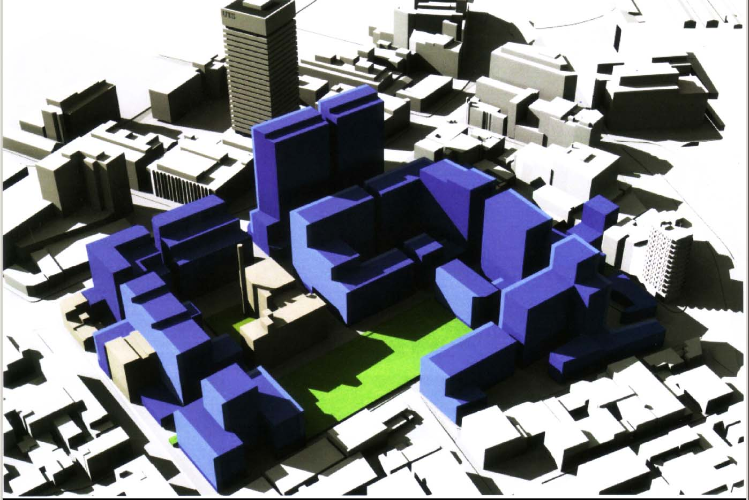

Following are documents and media stories (to 9 June) relating to the CSPC’s decision to hand the CUB site to the Minister for Planning. If you wish to read the document, (control +click) on the link

.Letter from City of Sydney (CoS) to DIPNR - 18 July 2005
Copy letter from CoS to the Director General, Department Infrastructure Planning and Natural Resources (DIPNR) dated 18 July 2005 - requesting clarification on the developer contributions (RWA levy) that are legislated to be paid to the Redfern Waterloo Authority (letter attached to the Lord Mayor's response to Minister Sartor’s letter dd 2 June 2006). This letter has an OCR text overlay so text can be copied if required. As this is produced by OCR it may contain some errors so please check the text carefully if using. File is 126 Kb PDF.
Letter from Minister Sartor to CoS and CSPC dated 25 May 2006
Copy letter from Minister Frank Sartor's dated 25 May 2006 to CSPC raising concerns about the CoS handling of the CUB application (Attachment A at the CSPC Meeting). This letter has an OCR text overlay so text can be copied if required. As this is produced by OCR it may contain some errors so please check the text carefully if you plan to use the text. File is 265 Kb PDF.
Letter from Clover Moore to Frank Sartor - 2 June 2006
Copy of letter from Clover Moore in reply to Minister Frank Sartor's letter of 25 May 2006. (attachment B at the CSPC Meeting). This letter has an OCR text overlay so text can be copied if required. As this is produced by OCR it may contain some errors so please check the text carefully if you using as text. File is 190 Kb PDF.
Decision of the Central Sydney Planning Committee (CSPC) - 7 June 2006
Copy of decision from CSPC meeting – specifically item (d) handing site back to the Minister.
City of Sydney calls public meeting for 15 June 2006 on CUB
Notice from CoS about the Public Meeting on Thursday 15th June at Medina Executive Hotel, at 2 Lee Street.
Coalition Chippendale Groups Notice re CoS Meeting - 15 June 2006
Community notification urging people to attend the Public Meeting organised by the COS in response to concerns about the CSPC voting handing control for the CUB site to the Minister for Planning.

Media Statements and Media Stories

State Government Action Threatens CUB Site - 2 June 2006
An eleventh hour grab for cash by the State Government is jeopardising two years of careful planning to set development controls and achieve community benefit from redevelopment of the historic Carlton and United Breweries (CUB) site at Chippendale reports Clover Moore in her E-News and a media statement.
Sartor slammed over CUB - The Australian June 03, 2006.
Sydney Lord Mayor Clover Moore accused NSW Planning Minister Frank Sartor of making a multi-million-dollar "cash grab" yesterday by contemplating higher density at Foster's Group's $1 billion-plus CUB site development in Sydney's Chippendale, in exchange for higher affordable housing levies.
Carlton & United Breweries Site Heritage Under Threat from Minister:
Media release dated 8 June issued by Andrew Woodhouse, President, Australian Heritage Institute Inc. - an Australia-wide umbrella group of local heritage societies.
Frank Sartor’s comments on CUB to Adam Spencer on 702 ABC - 9 June 2006
The following is a transcript of Minister Sartor's comments about the CUB site following a discussion about changes to Basix for high rise buildings.
Slum city fears as Sartor grabs massive project - 9 June 2006 – SMH 9 June 2006
The Minister for Planning, Frank Sartor, is set to take control of the city's biggest residential project, igniting fears he will allow enormous apartment blocks that will become Sydney's future slums reports Sherrill Nixon Urban Affairs Editor in the Sydney Morning Herald June 9, 2006.
Minister Steers Government Toward Another Cross City Tunnel Disaster - 9 June 2006
Lord Mayor Clover Moore MP Media release dated 9 June 2006 calling on the Minister for Planning to come clean on just how much money the State Government was planning to take from the CUB site, and to give assurances about how this money would be spent.

These documents have been collated, courtesy of REDWatch and can be found on their website - CSPC hands CUB to Minister - 7 June 2006.

To contact the Coalition Chippendale Community Groups, email – communityworkingparty@yahoo.com.au. For urgent enquiries, contact Jeanette on 0412 191 33, Dave on 0408 223 634 or Lindsay 0412 204 968

