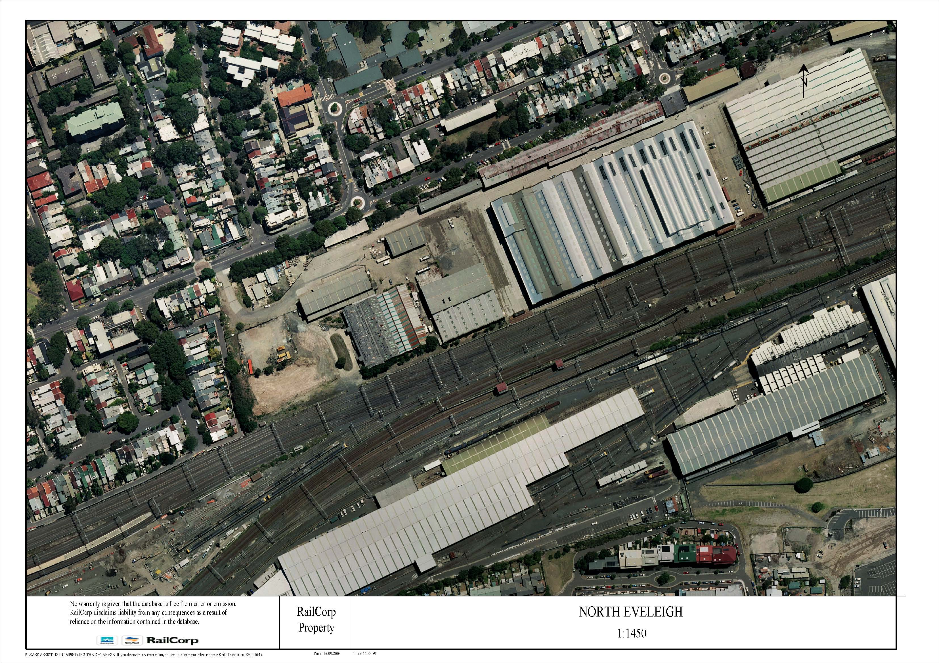
Stores Buildings
Carriage Shop Extension
Boilermakers Shop
Wilson St
Legend
Site Access
Demolition Site
Buildings to be Demolished
Buildings to be Demolished
Figure 1
Demolition Site Location

