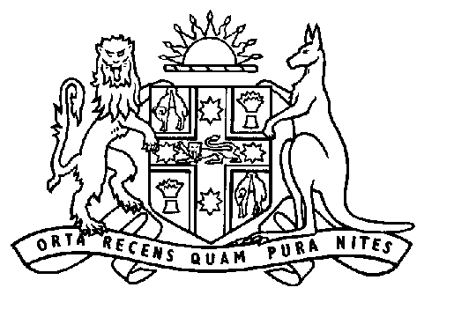
Matt Brown
Minister for Tourism
Minister for Housing
Member for Kiama

Wednesday January 9, 2008

REDFERN’S $28 MILLION HOUSING REDEVELOPMENT UNDERWAY

State Plan Priority R4: Building Harmonious Communities
State Plan Priority E6: Housing Affordability

Minister for Housing, Matt Brown today announced the demolition of old public housing buildings in Redfern is underway to make way for better, greener homes for those in need.

Mr Brown today visited the site and met with tenants and demolition contractors RK Civil and Environmental Engineering.

“This marks a significant step in our $28 million dollar investment in the local community, rejuvenating an important part of Redfern by providing attractive homes for tenants and opening up the area for new private development,” Mr Brown said.

“There are currently 88 units on the site in 10 separate buildings, each two to four storeys high.

“These units, built in the 1950s are no longer suitable housing for our tenants and are also very expensive to maintain.

“The demolition contractor has secured the site and begun the careful process of taking the buildings apart.”

Mr Brown said the contractor has lodged a detailed demolition plan with Housing NSW to clear, level and have the 9,709 m² site ready for the start of construction.

“The work to demolish the buildings and prepare the site is expected to take four months, with the construction of the 106 new public housing dwellings due to start in August 2008,” Mr Brown said.

Ms Keneally said the new housing will be better suited to local people in need such as the frail aged, people with a disability and smaller families.

“There will be a mix of small, multi-storey buildings, with 66 homes for elderly tenants and 40 terrace houses with backyards for families,” Ms Keneally said.

“What is also great about this project is that it is the most environmentally sustainable Housing NSW development to date.”

Media Contact: Andrew Vickery 0417 650 158

