Waterloo Community Engagement Proposal
By The (former) Waterloo Neighbourhood Advisory Board
Background
During 2008 Waterloo Neighbourhood Advisory Board carried out a series of consultations to develop a proposal for future ‘community engagement’ strategies and on how to increase resident involvement in local decision making processes. This information sheet summarises the proposal to be implemented and to be piloted over the course of 2009.
Basic concept
There are a range of different partners seeking to engage with Waterloo and Redfern residents/public tenants on various community issues with differing levels of perceived success. These include local member Kristina Keneally MP, Lord Mayor Clover Moore, Redfern Waterloo Authority/Implementation Senior Officers Group, City of Sydney, Police and various Government and NGO bodies.
This proposal is about improving the coordination of engagement within the Waterloo area. Implementation would be steered by a local working group. The Local Working Group will include members from the previous NAB Board, other local social housing and private sector residents, key ‘lead’ agencies, and local community development workers.
Structure
A request has been made for a total of four public community forums a year. These forums are for agencies to be invited to answer general questions on local community issues. We are seeking to have these forums chaired on a rotational basis between the Lord Mayor and the Local Member. In addition to the forums smaller ‘thematic’ working or action groups will be established to tackle specific community priorities which were identified by the NAB’s consultations in 2008. These themes include: - Housing, Community safety, Learning, Employment and Enterprise, and Community Health. These priorities would be reviewed bi-annually, and in due course protocols for membership, agreed standards of engagement, and good practice guidelines, would be developed.
What do we mean by the term Action group?
Community Action Groups (CAG s), bring together local residents with frontline community workers, policy makers, volunteers, community groups, and government and Non government agencies. Through joint thinking, we are more likely to reach effective problem-solving solutions. We would discuss problems together and through joint resources, ideas, motivation and commitments, we will bring real results. Action groups are an effective way to build momentum for change.
These action groups would meet bi-monthly and focus on steering achievable projects that are ‘outcome’ rather than ‘process’ focused. They would utilise a community ‘report card’ mechanism for tracking progress and reporting back through the quarterly community forums where local residents could give feedback.
Membership would be open to all those who want to positively contribute to the process, and decision making would be taken by a majority of votes, if required.
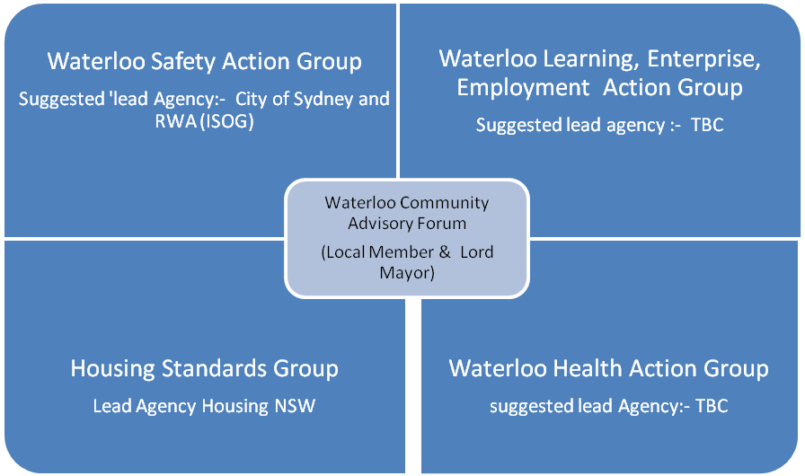

Links need to be maintained with other groups that have Community Engagement focus but run independently of the process above including
- REDWatch Group meet monthly
- Local media groups like Redwaternews &, SSH,
- Relevant cultural groups/ structures including, CALD / ATSI (Organise specific consultation meetings with existing groups quarterly)
- Redfern Local Area Command Safety Group
- South Sydney Inter-Agency (IRCSD)
- Community development workers Network(IRCSD)
- Political meeting by elected members both local /State
- Implementation Senior Officer Group (RWA)
- Ministerial advisory Groups (RWA)
- City of Sydney forums
- Housing NSW area Forums
- Central Sydney PTC
- Other Government and non Government Forums that are local and Regional
- Local Event and project coordination groups
- Mental Health Forums

So what are the main focus areas for the individual action groups?

Community Safety Group Focus
- Anti social behaviour and related effects particular Fear levels
- Continuation and Evaluation of the Waterloo Green Action Plan been extended across the area
- General Crime prevention

Employment, Learning, Enterprise Group Focus
- Volunteering Promotion
- Community Learning Coordination.
- Community Enterprise projects

Community Health Focus
- Heath promotion Projects
- Food Security Projects
- Social Isolation Reduction
- Mental ill health support projects

Housing Standards Focus
Will focus on driving Housing NSW Tennant participation strategies locally utilising and continuing the precinct election model covering:-
- Communal Maintenance
- Housing policy and practice
- Estate environment issues
- Relationship with local and regional teams / Issues

Schedule Proposal
Group | Date/ Time | Venue | Chair
Waterloo Community Advisory Forums  (Waterloo CAF) | Thursday 14th April 2pm  Thurs 11 June  10 - 11.30 am  Thursday xx Sept (TBC)  Fri 20 Nov  10 - 11.30 am | Waterloo Neighbourhood centre  Factory Community Centre  TBC  Factory Community Centre | Local Member  Lord Mayor  Local Member  Lord Mayor
Waterloo Safety Action Group | Wed 18th March 09 2pm  Wed 15th July 09 2pm  Wed 18th Nov 09 11am | Waterloo Neighbourhood centre  Factory Community Centre | City of Sydney/RWA
Waterloo Health Action Group | Friday 1st May 09 10am  Friday 3rd July 10am  Friday 23rd October 10am | Factory Community Centre | HCP / DADHC/ Health (TBC)
Housing Standards Group | First Tuesday of every month  3- 4:30 | Waterloo Neighbourhood Centre | Local Housing NSW Team Leader
Learning, Employment, Enterprise Action Group | Wed 29th April 11am  Wed 3rd June 2pm  Wed 21st Oct 11am | Factory Community Centre | HCP/ TAFE outreach (TBC)

Please note the above dates are correct at the time of print and are subject to change as directed by those involved in the individual groups. Please keep in touch for regular updates. Should you require any more information please contact us through the HCP worker at the Factory Community Centre on: 9698 9569
The steering group will endeavour to market and any additional/ reminders of meetings or changes to the schedule through the use of posters, emails, media coverage and websites.

